Chapter 01 - Inception

Theory -

● What is Emmet?

Most text editors out there allow to store and re-use commonly used code chunks, called “snippets”.

Emmet is **a free add-on for your text editor that allows you to type shortcuts that** are then expanded into full pieces of code.

Support for [Emmet](https://emmet.io/) snippets and expansion is built right into Visual Studio Code, **no extension required**.

More information regarding Emmet with respect to VS Code IDE can be found on

<https://code.visualstudio.com/docs/editor/emmet>

● Difference between a Library and Framework?

Both frameworks and libraries are code written by someone else that is used to help solve common problems.

A library is like you already have your own code, but you need a bit of help with some features of that library, which can make your code faster and scalable. You don’t feel like making your everything from scratch due to time crunch. Library allows you to pick and choose different things to go in your code. You are in control.

A framework, on the other hand, is like building a code. You have a set of architecture and design with limited choices. Ultimately, the framework is in control. And it will let you know when and where you can provide your input.

The technical difference between a framework and library lies in a term called inversion of control.

More details about Inversion of Control can be found on this video by Akshay Saini, who beautifully elaborated Callback Hell & Inversion of Control-

<https://www.youtube.com/watch?v=yEKtJGha3yM>

In short, A framework inverts the control of the program. It tells the developer what they need.

A library doesn’t. The programmer calls the library where and when *they* need it.

● What is CDN? Why do we use it?

CDN stands for Content Delivery Network. The Origin server is the server where original web files are placed. In the absence of CDN, if the user sends request directly to the origin server, the client will have to wait for the request to be fulfilled depending upon the geo location of the client and server. Also, website’s work load will increase. CDN also protects from online attacks by masking the original server making primary data source practically invisible.

With a CDN, static and dynamic content, large file downloads, etc **can be cached (saved for some time)** in multiple locations at once, on servers all over the world. These locations are known as PoPs (Points of Presence), sometimes also as edge locations and they are **strategically located in populated areas** with the most demand.

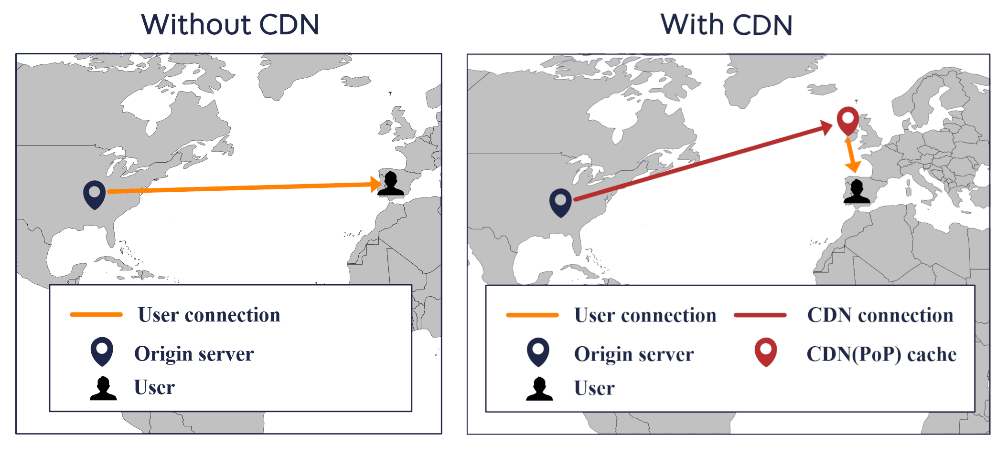

Why do we use it?

1. CDN is key to a fast and responsive site
2. It will [lower your cost for data transfer](https://www.stormit.cloud/blog/aws-data-transfer-pricing-how-to-reduce-costs/) from your origin server because the most desired content will be cached in PoPs and your origin server doesn’t have to serve as many requests as it would normally do.
3. Protect not only your content but also your infrastructure behind it.
4. Protects your origin server from traffic spikes and it is easily and automatically scalable to your needs.
5. Data that should be accessible to your users at any time are replicated on multiple servers, so if your origin is unavailable, PoPs can easily manage that for you.

● Why is React known as React?

React is a JavaScript library for building user interfaces.

React is named “React” because:

* It "reacts" quickly to changes without reloading the whole page.
* It uses the virtual DOM to efficiently update parts of a webpage.
* It’s built around components that "react" and update.

● What is crossorigin in script tag?

The **<script> crossorigin Attribute** is used for loading an external script into their domain from a third party server or another domain with the support of HTTP **CORS Request.** This attribute is used to protect sensitive information from the third party when fetching out the results.

Cross-Origin Resource Sharing(CORS) is a tool that allows web pages requesting for resources from another domain that is outside of their own domain. It is also used for managing cross-origin requests which is a request for a resource from an outside domain.

● What is diference between React and ReactDOM

● What is difference between react.development.js and react.production.js files via CDN?

● What is async and defer? - see my Youtube video ;)

Coding -

● Set up all the tools in your laptop

○ VS Code

○ Chrome

○ Extensions of Chrome

● Create a new Git repo

● Build your first Hello World program using,

○ Using just HTML

○ Using JS to manipulate the DOM

○ Using React

■ use CDN Links

■ Create an Element

■ Create nested React Elements

■ Use root.render

● Push code to Github (Theory as well as code)

● Learn about Arrow Functions before the next class

References:

- https://beta.reactjs.org/apis/react/createElement

- https://www.youtube.com/watch?v=IrHmpdORLu8